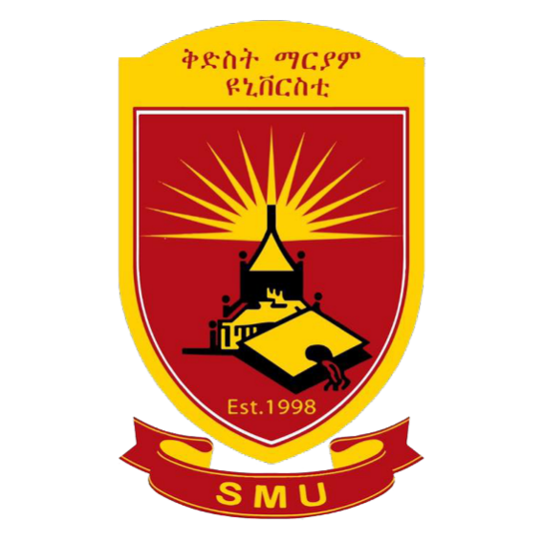

St, Mary’s University

Computer science department

Programming Fundamental I Assignment

Car Rental System

Section: RCD2017A

Group: 2

Code: CoSc 1012

NAME ID

1. Bethelhem Zewdu RCD/0239/2017
2. Bethlehem Bekinew RCD/0240/2017
3. Eleni Fikere RCD/0249/2017
4. Eyerus Chemer RCD/0254/2017
5. Melat Alemneh RCD/0267/2017
6. Seblewongel Abera RCD/0272/2017
7. Hafsa Muhab RCD/0258/2017
8. Ephratah Yohannes RCD/1823/2017

Submitted to: Mr. Dawit

Submitted by: 9/July/2025 _